Name –  Mentor Group –  The Social Media Platforms I use–  -  -  -  -  Workshops attended –  -  -  -  - | Sexting - Implications & The Law  Task – What does your Slogan Say to Sexting and it’s seriousness? Create one…  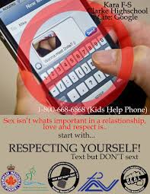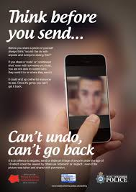 | Cyber Abuse/Bullying  Task – ‘What is Brodie’s Law?’  Follow the link and answer the questions below:  Brodie's Law  What is it?  Why do we need it?  What should you do if you are being bullied?  What should you do if someone else is being bullied?
Online Gambling  Task – Create an advertisement to oppose this online gambling phenomenon and open the next generations eyes to the possible impacts.  Risks –  - Start gambling at a young age  - Have a big win in the early stages of gambling  - Are around gambling often and receive pressure from peers to gamble. | Balancing Online Time  Task – Creative Drawing  Step 1 – Draw an ‘online’ activity  Step 2 – Draw 2 productive offline activities  Repeat!  - On… 2) Off………. | Digital Reputation  Task – ‘Mirror, mirror on the wall’  Draw your Mirror and fill it with words to describe the digital reputation you aspire to have.
Empathy Challenge Pledge – ‘the ability to understand and share the feelings of another’
Task – I will show empathy towards my friends and peers by…….(finish this pledge in your own words)

