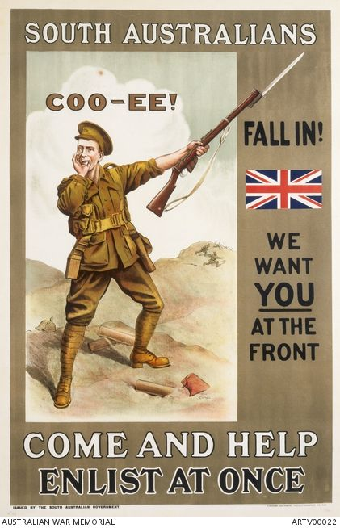

Australians had an image of themselves as tough pioneers. In an era that uncritically viewed the occupation of Indigenous lands, Australians found their most persuasive stories in settlement, exploration and the gold rushes. Poetry and paintings celebrated abilities like riding a horse and shooting a rifle. There was a powerful mythology of war being the event that turned boys into men.

# BOY OR MAN?

August 2015 – Patriotism, Pioneers, Moral Crusade