Humanities WW1

Letters From the Trenches - Western Front.
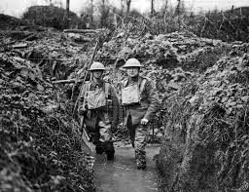
Letters from BRITISH soldiers:
- The soldiers at the front need more rest. While in the trenches the water is over our knees most of the time. The war is going to last some time yet, and might be another twelve months before it is over. The war has only just begun and it's going to be a war of exhaustion. After the regular armies have done their work it means that all the young lads at home being trained and disciplined and will take our place in the field. The sooner people understand this, the better, it will be for the nation.
Private H. F. Leppard in a letter to his mother on December 19th, 1914

- We have just come out of the trenches after being in for six days and up to our waists in water. While we were in the trenches one of the Germans came over to our trench for a cigarette and then back again, and he was not fired at. We and the Germans started walking about in the open between the two trenches, repairing them, and there was no firing at all. I think they are all getting fed up with it.
Private Stanley Terry in a letter to his family in November, 1915

Letters from AUSTRALIAN soldiers:
- We started away just after dawn from our camp and I think it was about an hour later that we encountered the enemy. They were on the opposite side of the valley and as we came over the brow of the hill they opened on us with rifle fire and shrapnel from about 900 yards. We lost three officers and about 100 men killed and wounded in that half hour. I do not want any more days like that one. Anyway we drove the Germans back and held them there for eight days. I cannot tell you all I should like to, as it would never reach you.

Private James Mitchell in a letter to his father on October 17th, 1914.
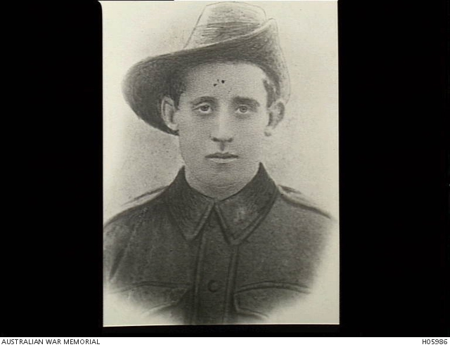

- It was awful just in the part of the line where we were (where the big push was on). The mud was up to our hips and when we got wet we stopped wet, but they say mud keeps one warm. It does when we get a big issue of rum and some “tucker”. When I got down to the field ambulance you never saw the like, I was mud from head to feet, hands and face included. I had not had a shave or wash for about 10 days. I could hardly walk and Fritz had been putting as much mud on me as he could with his wiz-bangs 5.9 and 9.2 bursting all around. I think it was only the will of God that kept me as several times his high explosive shells fell “duds” just behind me.
George Davey of the 2nd Battalion.
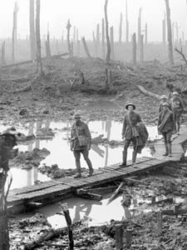

Letters From GERMAN soldiers.
- It is, indeed, not so simple a matter to write from the war, really from the war; and what you read … in the papers usually lack of understanding that does not allow a man to get hold of the war, to breathe it in although he is living in the midst of it. The further I penetrate its true inwardness the more I see the hopelessness of making it comprehensive for those who only understand life in the terms of peacetime, and apply these same ideas to war in spite of themselves. They only think that they understand it. It is as if fishes living in water would have a clear conception of what living in the air is like. When one is hauled out onto dry land and dies in the air, then he will know something about it. So it is with the war. Feeling deeply about it, one becomes less able to talk about it every day. Not because one understands it less each day, but because one grasps it better. But it is a silent teacher, and he who learns becomes silent too. Rudolf Binding, letter (April, 1915)
- 'I have witnessed much in this greatest war but the goal of my war experience, the storming attack and the clash of infantry, has been denied me so far. Let this wound heal and let me get back out, my nerves haven’t had enough yet!
- This area was meadows and forests and cornfields just a short time ago. There’s nothing left of it, nothing at all. Literally not a blade of grass, not a tiny blade.' 'Every millimetre of earth has been churned up and churned again, the trees uprooted and torn apart and ground to sludge. The houses shot to pieces, the bricks crushed into powder. The railway tracks turned into spirals, hills flattened, everything turned to desert.' And everything full of corpses who have been turned over a hundred times. Whole lines of soldiers are lying in front of the positions, our passages are filled with corpses lying over each other in layers.'
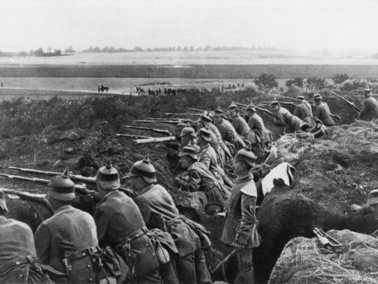
Letters from Nurses of the Western Front
- Every night there are two or three deaths, sometimes five or six; its just awful flying from one ward into another … each night is a nightmare, the patients’ faces all look so pale with the flickering ship’s lights.
- Ella Tucker, in Bassett, Guns and Brooches, p.44

- I shall never forget the awful feeling of hopelessness on night duty. It was dreadful. I had two wards downstairs, each over 100 patients and then I had small wards upstairs — altogether about 250 patients to look after, and one orderly and one Indian sweeper. Shall not describe their wounds, they were too awful. One loses sight of all the honour and the glory in the work we are doing.
- Lydia King, in Goodman, Our War Nurses, p.39

- We return to Imbros to discharge our light cases, once more return to be refilled … We are well under fire many bullets coming on the decks. I was speaking to one boy, moved away to another patient when a bullet hit him and lodged in his thigh. It just missed.
- Daisy Richmond, in Cheryl Mongan and Richard Reid, We have not forgotten, p.152
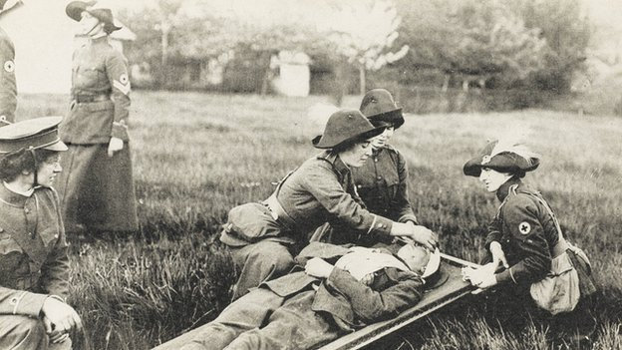
Letters from French Soldiers
Eventually soldiers on all sides could not endure this hell. Part of survival ultimately depended on refusing to obey orders, even as their officers promised to shoot them on the spot should they not advance. Soon troops from both sides exited the trenches, met their enemies in peace and even agreed not to fire on one another. Barthas came upon “French and German sentries seated tranquilly on their parapets, smoking pipes and exchanging bits of conversation from time to time, like good neighbors taking some fresh air at their doorsteps.”
http://www.thedailybeast.com/articles/2014/05/01/blood-and-mud-a-french-soldier-s-wwi-memoir-vividly-describes-trench-warfare.html

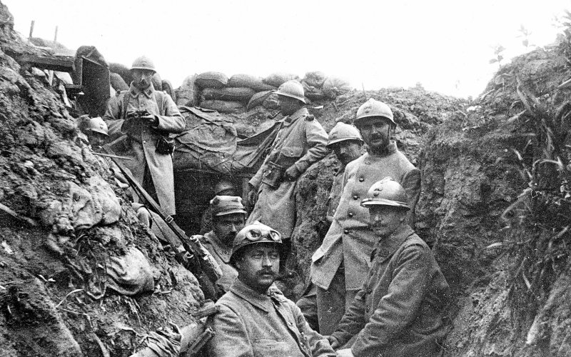

The Conditions for soldiers during the trench warfare stage were extremely vile and putrid. Can you gather any information from your letter about the condition for that particular soldier?

What is the author's purpose?
What vocabulary can you pick up from the letter? What stands out? What tone do you think the writer is using?
How were letter sent and delivered during trench warfare of the Western Front?

http://spartacus-educational.com/FWWletters.htm

Soldiers were encouraged to write letters to friends and family.. Most men decided it would be better to conceal the horrors of the trench warfare. As a result of the Defence of the Realm Act that was passed in 1914, all letters that the men wrote should have been read and censored by junior officers.

Why do you think letters needed to be censored?

